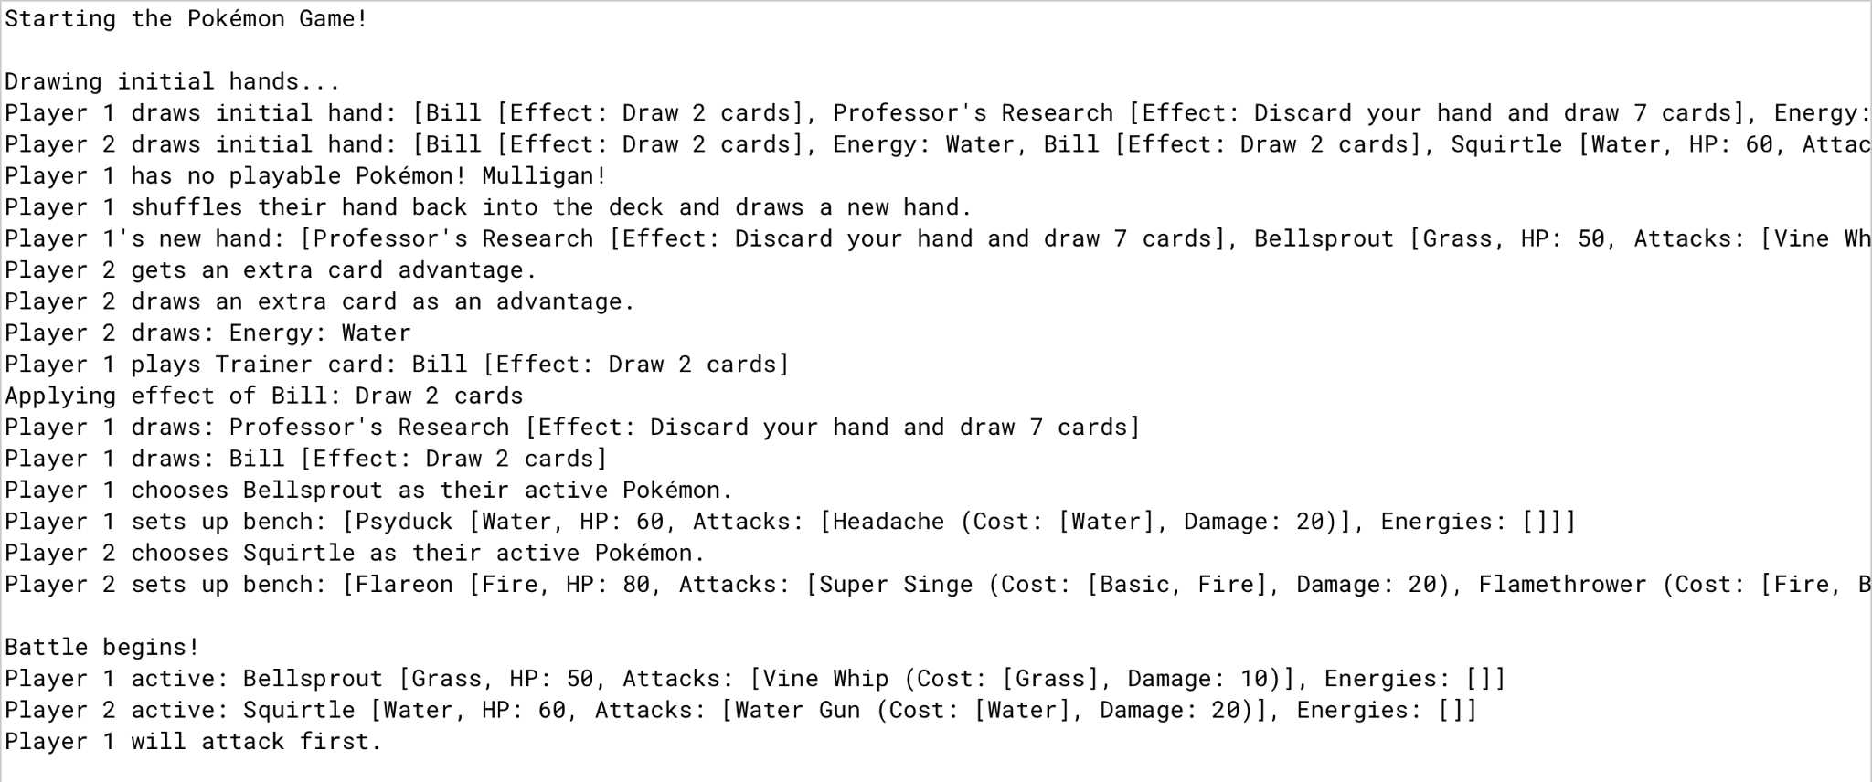

In the screenshot, you can see the program performing its initial setup for the Pokémon TCG simulation. First, each player draws a seven‑card hand from their deck. If a player’s hand has no Pokémon, that player must take a mulligan by shuffling their hand back into the deck and drawing a new seven‑card hand. Meanwhile, if the other player’s hand is valid, they draw an extra card as an advantage. Once both players have at least one Pokémon in their hand, they each select an Active Pokémon (and optionally place additional Pokémon on the bench). With those steps complete, the game is ready to begin, and a coin flip decides who will attack first.

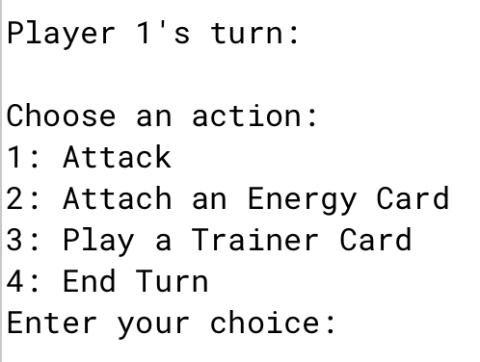

In the screenshot above, you see the menu of actions available each turn in the Pokémon TCG simulation. Option **1: Attack** lets you review your Pokémon’s available attacks and select one to perform, provided you have the required Energy attached. Option **2: Attach an Energy Card** is crucial because many attacks need specific energy types before they can be used. Placing the correct Energy cards on your Pokémon ensures you meet those requirements. Option **3: Play a Trainer Card** offers a special benefit—like drawing extra cards or healing—if you have Trainer cards in your hand. Finally, option **4: End Turn** simply concludes your turn and passes play to your opponent.

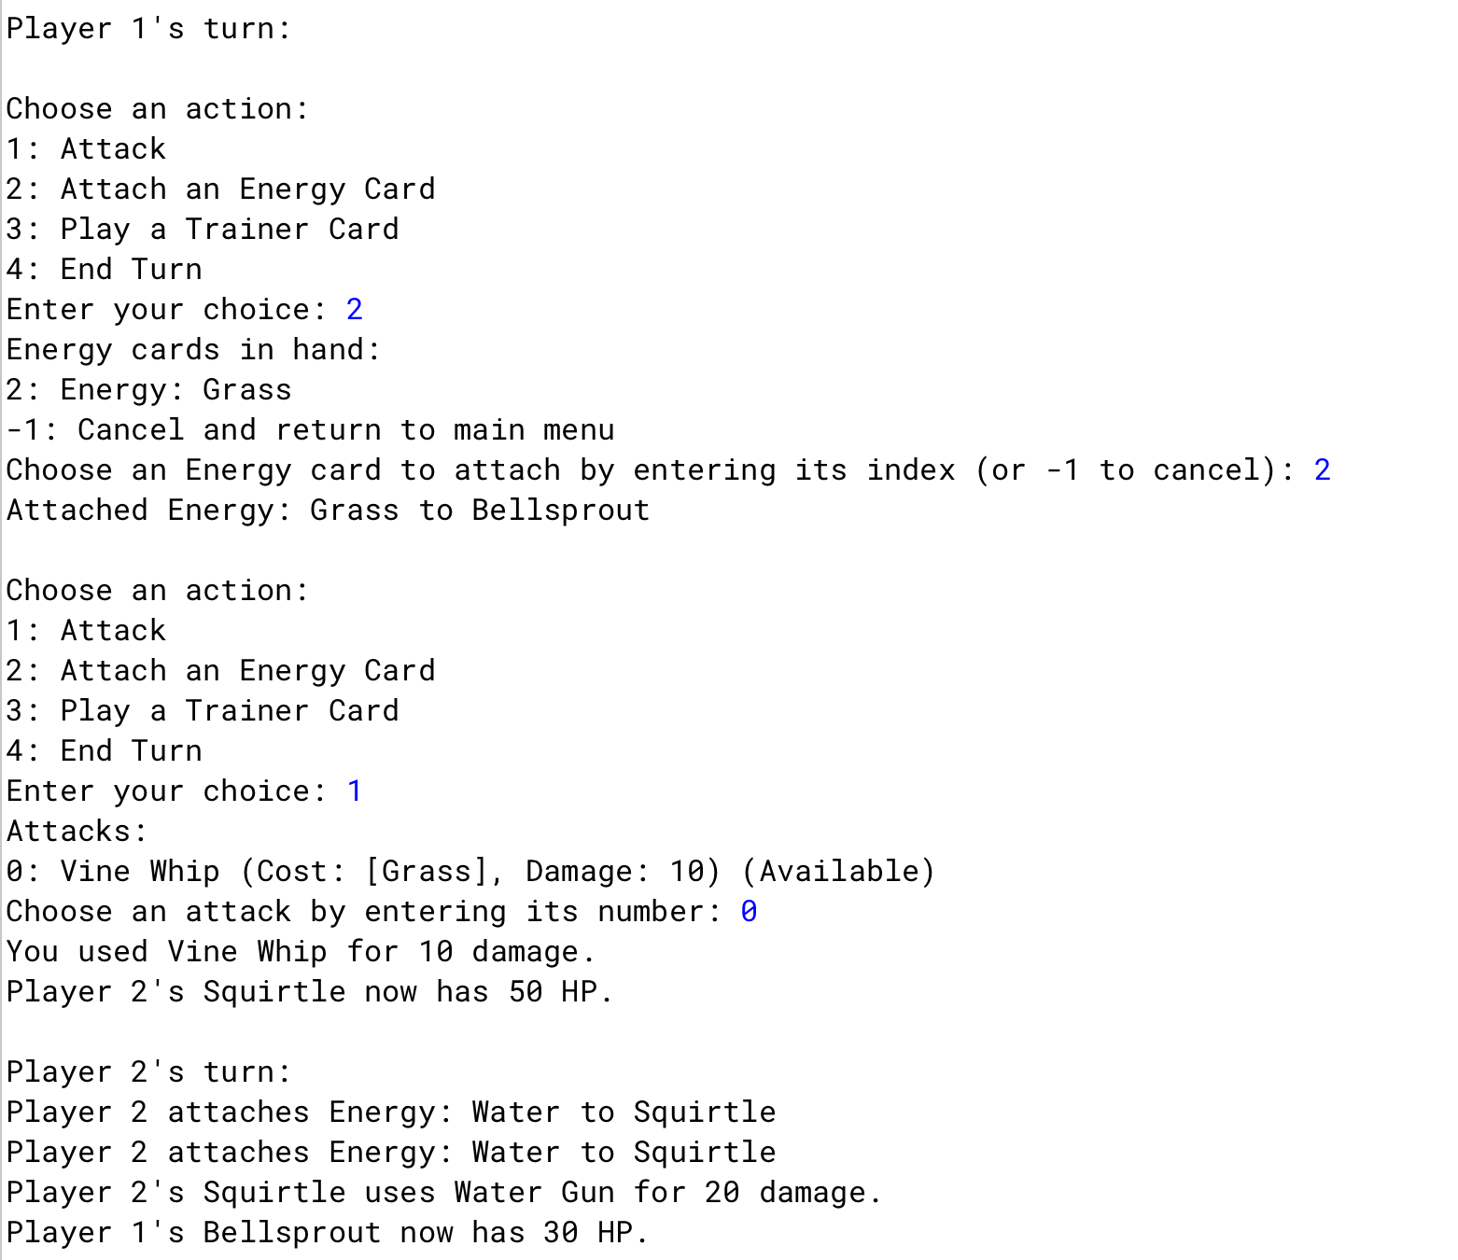

This screenshot just displays the interface of what prompts during battle. As shown you can see the previous options you choose and when attacking the opponent's pokemon, It prompts what attack you used, how much HP the opposing pokemon has and how much damage you did with your attack to the opposing pokemon.

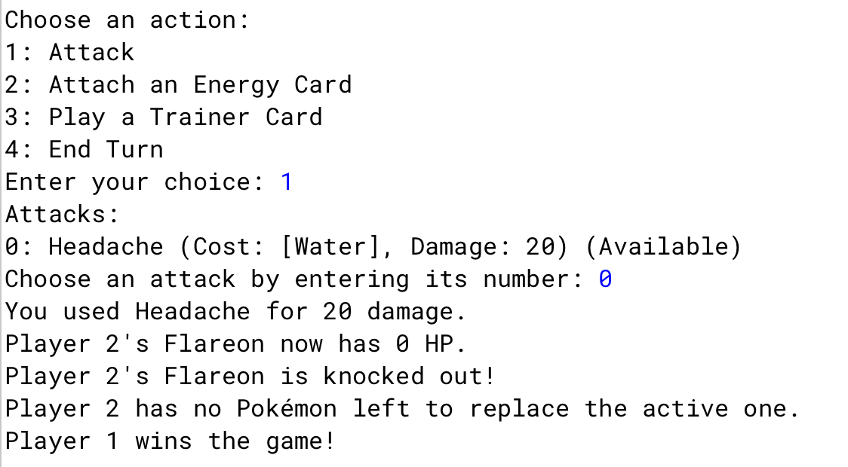

This screenshot shows what happens when you win the game. Once your opponent has no more playable pokemon then you will be prompted with this screen which displays that you have won the game!